United States Department of the Interior
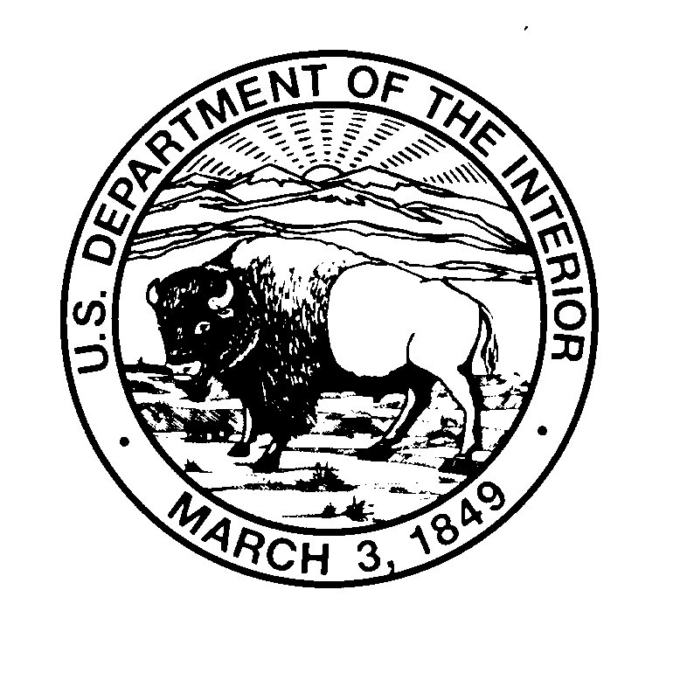

U. S. GEOLOGICAL SURVEY
BIOLOGICAL RESOURCES DIVISION
COLUMBIA RIVER RESEARCH LABORATORY
5501-A Cook-Underwood Road

Cook, WA 98605 USA
(509) 538-2299

December 17, 2021

Operations Manager
U.S. Army Corps of Engineers
Bonneville Lock and Dam
P.O. Box 150
Cascade Locks, OR 97014

We would like to request access to the Bonneville Project for fishery research to be conducted from February to December 2022. The USACE has contracted with the U.S. Geological Survey (USGS) to collect smallmouth bass samples and evaluate the movements of smallmouth bass near Bonneville Dam using acoustic telemetry. This study is in support of a broader effort being conducted by USACE under the Comprehensive Environmental Response, Compensation, and Liability Act at Bradford Island. The USGS has been contracted to collect 40 smallmouth bass from the Bonneville Project Forebay (River Operable Unit) for tissue analyses, as well as 40 smallmouth bass for acoustic telemetry monitoring. Consequently, it is essential that we are able to access the Project for the collection and monitoring of these fish. We propose to install 13 acoustic telemetry fixed site monitoring stations within the River OU similar to the study in 2020. The required fish collection and transportation permits have been acquired and will be provided to the Bonneville Fisheries Research Coordinator, along with the project implementation plan and schedule of activities, project impact statement, activity hazard analysis, job hazard analyses, and lists of personnel, boats, and vehicles.

Sincerely,

Tobias Kock
Research Fishery Biologist

cc: Erin Kovalchuk; USACE
Andrew Derugin; USACE

